

AUTOID Swatch-2.0M4-9.0
PRODUCT SPECIFICATION V1.0

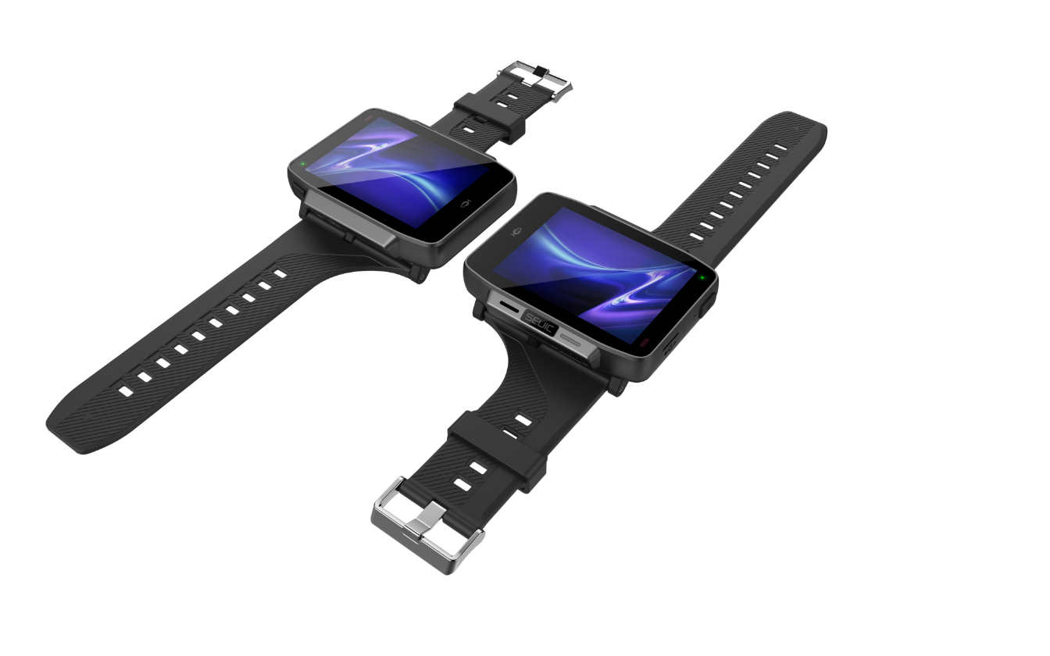
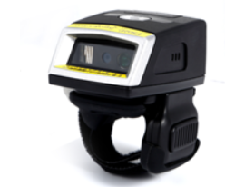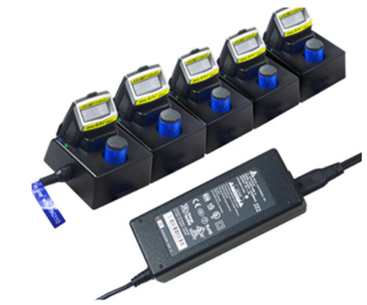

JIANGSU SEUIC TECHNOLOGY CO., LTD

AUTOID Swatch-2.0M4-9.0 Performance, Physical and Environmental Parameters
CPU | MTK 4-core 2.0GHz
Operating system | Android 9.0
RAM | LPDDR3 3GB
ROM | 32GB
Interface | TYPE-C
Keys | 2 keys (power supply, custom), 1 million times life
Screen | 2.8 inch full view LCD, capacitive 3-point touch.
Screen | The resolution is 640 × 480 and the maximum brightness is 350nit
Power Supply | Non detachable 3300mah lithium ion rechargeable battery, 500 cycles, capacity more than 80%
Audio frequency | Built in speaker, 8 Ω, 1 W * 1. Built in dual microphone
Sensor | Acceleration sensor, proximity light sensor, electronic compass, gyroscope, barometer. Support to raise your hand to light up the screen.
Vibrating motor | support
Size | 54.7*80*17mm
Weight (including standard battery) | 100 g No strap
Working temperature | -20℃ to +60℃
Storage temperature | -30℃ to +70℃
Humidity | 5% to 95% RH No condensation state
Waterproof and dustproof industrial grade | IP67
Drop Level | 1.2m Marble Falls, 5 rounds on 6 sides, 30 times
Electrostatic discharge (ESD) | Air discharge of ± 15kV and direct discharge of ± 8Kv

AUTOID Swatch-2.0M4-9.0 Data Acquisition Function Parameters
Function 1 | Geographic Location Information Collection
Location | GPS + GLONASS + Beidou + galileeo, support AGPs
Working mode | GPS main positioning, Beidou, GLONASS, galileeo auxiliary positioning
Frequency | GPS:L1(1.575GHz)；Beidou : B1(1.561GHz)； GLONASS:L1(1.602GHZ)
Time positioning | Cold start ≤ 40s, hot start ≤ 3S
Accuracy | 5-10m，open sky
Function 2 | Rear Camera Image Acquisition
Pixel | 1300 ten thousand
Photo taking function | PDAF, f = 2.0
Flash lamp | Flash, 1A flash, torch mode

AUTOID Swatch-2.0M4-9.0 Function Parameters of Wireless Data Communication
Function 1 | WIFI
Agreement | IEEE 802.11a/b/g/n/ac（2.4G/5G Dual frequency WIFI）
Frequency range | Depending on the country (region), 2.4GHz is usually 2.412ghz-2.472ghz; 5GHz is usually 5.170ghz-5.825ghz
Working channel | CH1~CH13，CH34-CH140，CH149~CH165
Security | OPEN、WEP、WPA2-PSK（TKIP+AES）、TLS、TTLS (MS-CHAP),、TTLS(MS-CHAP v2)、TTLS (CHAP)、TTLSMD5、TTLS-PAP、PEAP-TLS、PEAP(MS-CHAP v2)、AES etc.
Transmission distance | 2.4G greater than 50m, 5g greater than 40m (open area)
Data rate | 802.11a: 6,9,12,18,24,36,48,54Mbps  802.11b: 1, 2,5.5,11Mbps  802.11g: 6,9,12,18,24,36,48,54Mbps  802.11n: 6.5,13,19.5,26,39,52,58.5,65Mbps（20MHz,Long GI,800ns)  802.11n: 7.2,14.4,21.7,28.9,43.3,57.8,65,72.2Mbps（20MHz,short GI,400ns)
Function 2 | Wireless WAN
Frequency band | GSM：850/900/1800/1900  TD-SCDMA：B34/B39  WCDMA：B1/B2/B5/B8  CDMA：BC0  TDD-LTE：B34/B38/B39/B40/B41  FDD-LTE：B1/B3/B5/B7/B8  Support VoLTE
Function 3 | Wireless personal area network Bluetooth
Standard | Bluetooth 5.0 (dual mode, ble supported)
Distance | More than 20 meters

- AUTOID Swatch-2.0M4-9.0 THE THIRD PARTY APPLICATION DEVELOPMENT SUPPORT

System Software | Android 9.0
System programming environment | Android Studio

- AUTOID Swatch-2.0M4-9.0 PERIPHERALS AND ACCESSORIES

Standard Accessories | Charger ×1, TYPE-C Cable×1,Watch strap ×1,Steel film x1

